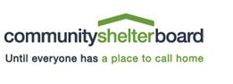

**ZERO INCOME STATEMENT**

I _____________________________________, understand that the information provided on this form will be used to determine income eligibility and cost of housing. I have read the clarification for what is considered income* and hereby certify that I am currently receiving no income from any source.

I certify that this statement is true to the best of my knowledge and understand that providing false, misleading or incorrect information may result in ineligibility for the Rental Assistance Program.

________________________________________ _______________________

Client Signature Date

*Income: Wages from job, self-employment, Social Security, Social Security Income (SSI), Pension/Veteran’s Administration (Military Pay), TANF/Ohio Works First (Public Assistance), Unemployment Benefits, Workers Compensation, Educational Financial Assistance (Financial Aid), Court Ordered Child Support Payments Received, Informal Child Support Payments Received and Alimony.

Client CSP ID: ________________